CLEANING AND INFECTION CONTROL PLAN

(Name of CBVCT)
Topic/Intervention |  | Product / Procedure | Con-cent-ration  % | Expo-sure time | Frequency | Method
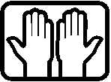 | Hand disinfection | e.g. Sterillium Virugard | Ready to use | 30 Sec. | Before the shift starts; before and after all diagnostic, therapeutic and care-related interventions with clients | Take at least 3 ml from the dispenser and rub into dry hands undiluted
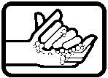 | Hand washing | e.g. Lifosan Soft | Ready to use |  | Only when hands are visibly dirty after hand disinfection; after using the toilet; as needed. | Liquid soap from the wall dispenser. Rinse soap residue thoroughly. Dry hands.
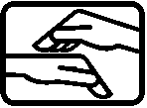 | Hand care | e.g. Trixo-lind | Ready to use |  | Several times per day as needed; at the end of your shift. | Apply a sufficient amount to the back of the hand and distribute evenly to both hands.
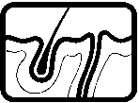 | Skin disinfection | e.g. Cutasept F | Ready to use | At least  15 sec. | Every time before skin prick or phlebotomy. | Wet puncture area, keep moist for at least 15 sec., then remove excess with cellulose swab (capillary blood) or sterile gauze swab (phlebotomy).
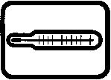 | Testing trays | e.g. Bacillol plus | Ready to use | 30 sec. | After each use. | Wet the entire surface. After exposure time, wipe off excess with disposable towel.
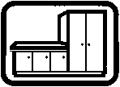 | Working surfaces, medical table/neck support, wall, equipment | e.g. Bacillol plus | Ready to use | 30 sec. | As needed; in case of contamination; at the end of the shift. | Wet the entire surface. After exposure time, wipe off excess with disposable towel.
Waste disposal | Sharps and fragile single-use equipment | Shatter and sharps proof container |  |  | After use or at the end of the shift | Dispose of according to local regulations.
Waste disposal | Medical waste (used test strips, swabs, plasters) | Waste bin with liner |  |  | After use or at the end of the shift | Dispose of according to local regulations.

